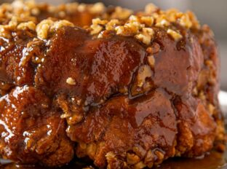
Gorilla Bread
Prep Time 20 min Cook time 45 min
16 Servings
Ingredients
½ cup granulated sugar
3 tsp cinnamon
½ cup butter
1 cup brown sugar, packed
8 oz package cream cheese
24 oz refrigerated biscuits
1 ½ cups walnuts, coarsely chopped (optional)
Directions
- Preheat the oven to 350 degrees and spray a bundt pan or square baking dish with vegetable oil spray.
- Mix sugar and cinnamon in a small bowl.
- In a separate microwave safe bowl, add the butter and brown sugar. Microwave and melt in 30 second increments until fully melted (approximately 1½ minutes), then stir well until combined.
- Cut your cream cheese into 20 pieces. Spread your biscuits into flattened circles on a large cutting board. Place a piece of cream cheese in each one and fold it closed over the cream cheese.
- Roll each closed biscuit in cinnamon and sugar and place it in the desired pan.
- If using a bundt pan, after ten biscuits, top the biscuits with half the nuts and half the butter mixture. Add the remaining biscuits. If using a baking dish, make one layer of biscuits.
- Top with the remaining nuts and butter/brown sugar mixture. Top with the unused cinnamon sugar.
- Bake for 45 minutes.
- Let cool for 5 minutes before removing from pan. If using a bundt pan, place plate upside down over the pan and flip very carefully.
Notes
Add in chocolate chips, chopped cookies, or candy pieces as desired.
Stuff with peanut butter and top with caramelized bananas instead of cream cheese.
Try using cinnamon rolls, buttermilk biscuits, or crescent rolls.
Serve with vanilla ice cream and drizzle with salted caramel sauce.
Gorilla bread can be stored at room temperature in an air-tight container for 2 days, refrigerator for 4 days, or freezer for 3 months.
To eat after frozen, reheat in a conventional oven.

